People don’t know the need for Boolean logic and ways of working with them, well ill tell you all about them. The basics are logic gates, there are 7 logic gates:

**AND**, **NAND**, **NOR**, **OR**, **XOR**, **XNOR**, **NOT**. These are used to change the values of inputs based on their respective conditions

Truth tables are used to display the possible outcomes of logic gates.

Logic gates are needed to apply conditions to inputs in a way that is understandable for humans (not binary).

|  |
| --- |
| A+0 |
| a.1 |
| a.0 |
| a.a |
| A+b |
| a.b |
| ~a |
| ~a.b |
| ~a+b |
| Ao+oB |

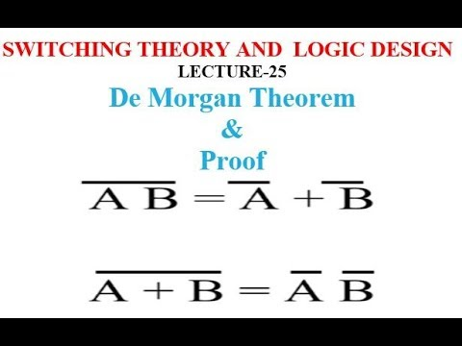Boolean expressions are most often used as conditions. And to solve Boolean equations and logic gates.

There are 10 rules in Boolean algebra.

De Morgan's Laws are supposed describe how mathematical statements and concepts are related through their opposites. It allows you to change gates around by following a set of rules which make the Boolean expressions more simplified.

We need Boolean expressions to know if a logical statement is either true or false.